**Job openings API Documentation**

If user is trying to access the data without being authenticated below error will be returned.

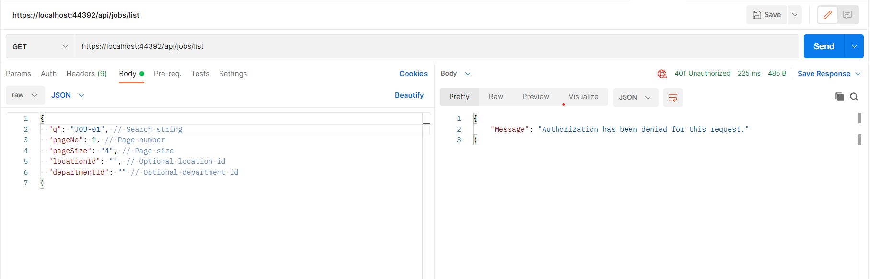

To get the token user need to pass the username & password

(Note: I have already created one record in the USERS table through which credentials will be validated)

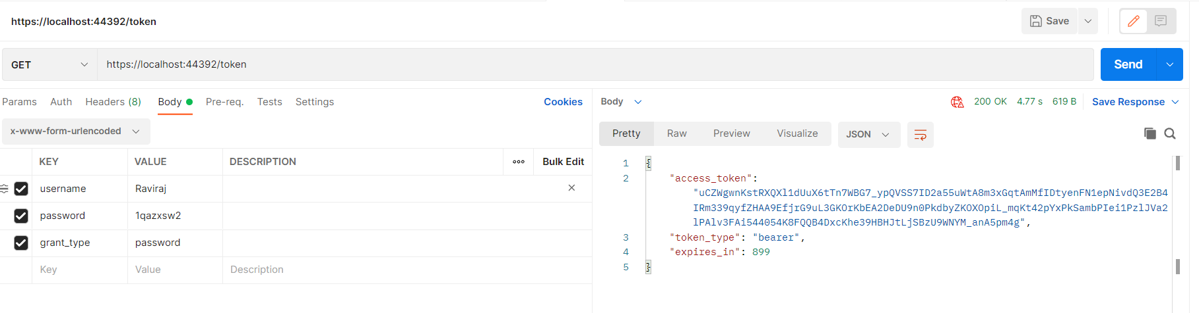

Using this token now we can access all methods

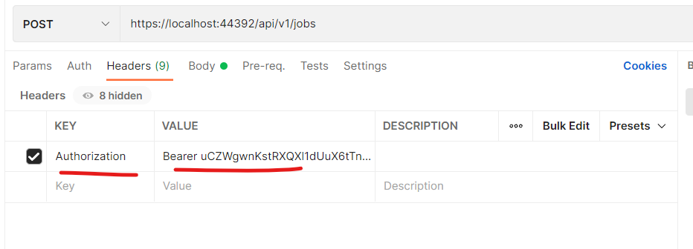

**POST /api/v1/jobs**

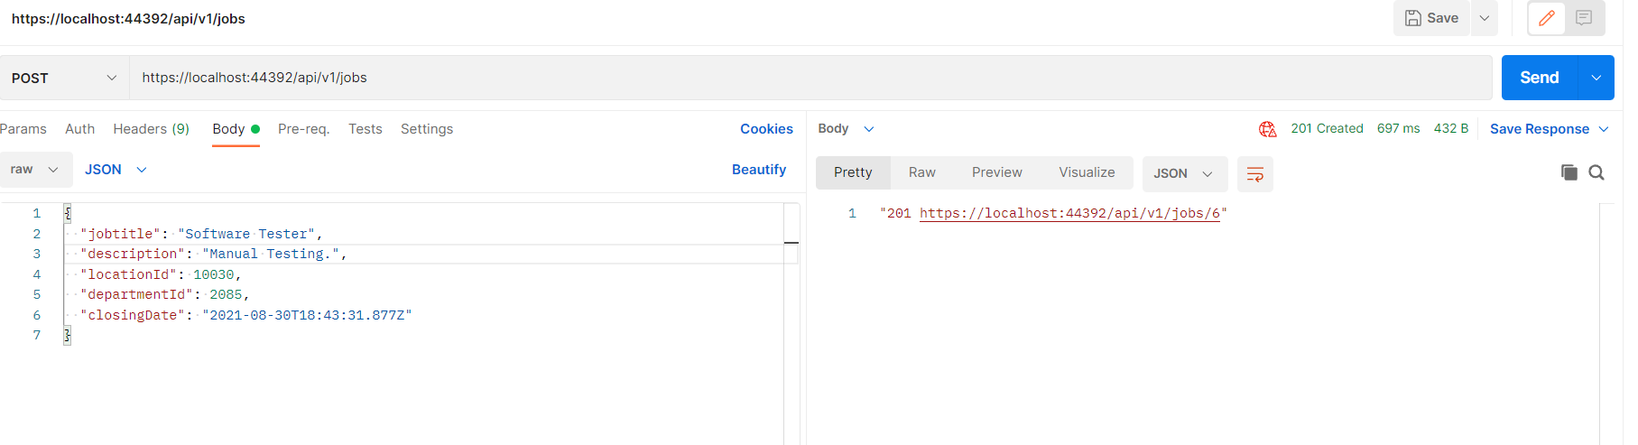



Request

{

  "jobtitle": "Software Tester",

  "description": "Manual Testing.",

  "locationId": 10030,

  "departmentId": 2085,

  "closingDate": "2021-08-30T18:43:31.877Z"

}

Response

"201 <https://localhost:44392/api/v1/jobs/6>"

**PUT /api/v1/jobs/{id}**

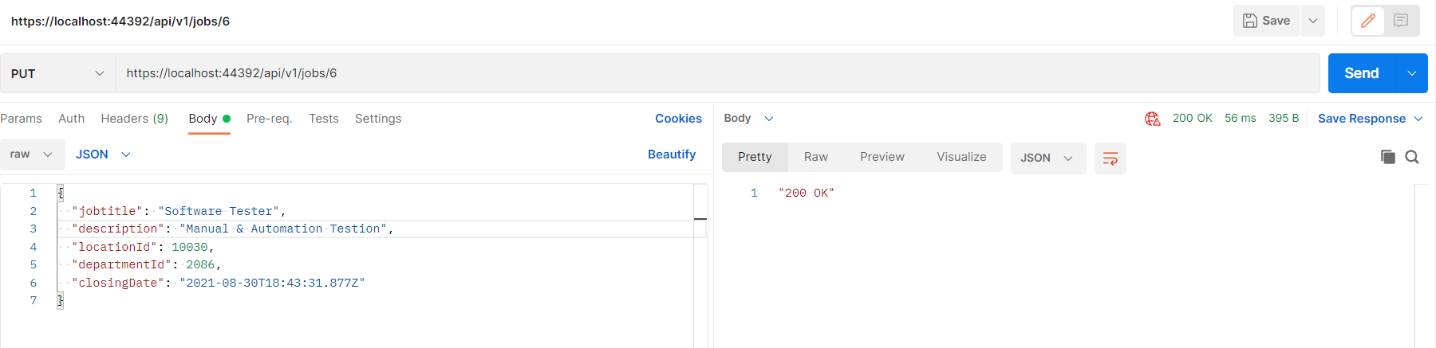



Request

{

  "jobtitle": "Software Tester",

  "description": "Manual & Automation Testion",

  "locationId": 10030,

  "departmentId": 2086,

  "closingDate": "2021-08-30T18:43:31.877Z"

}

Response

"200 OK"

**List API**

**POST /api/jobs/list**

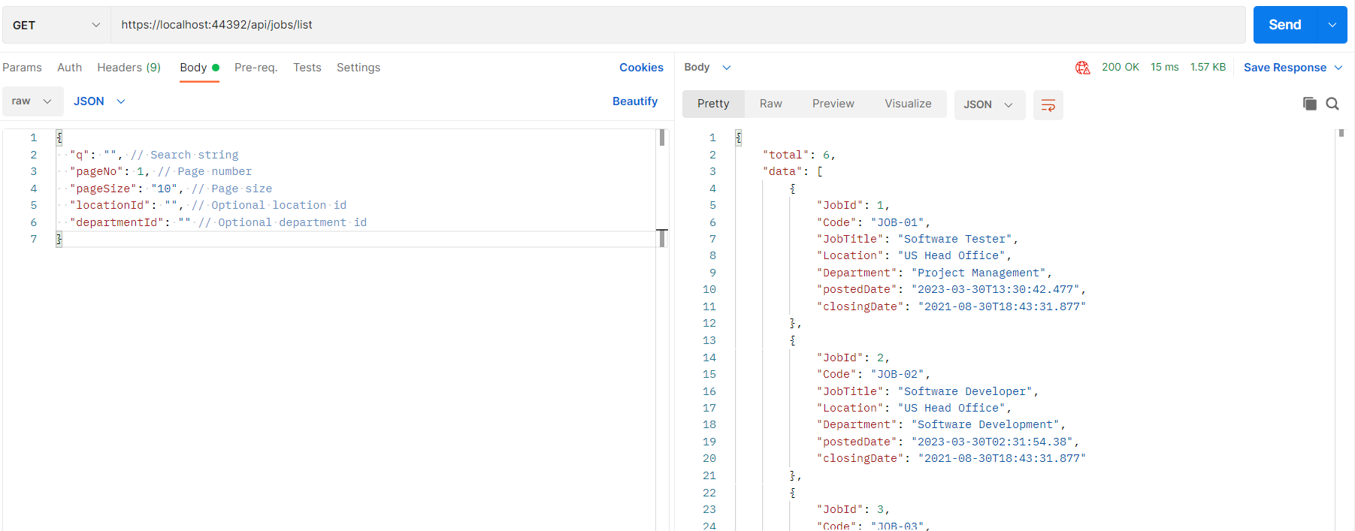

Request

{

  "q": "", // Search string

  "pageNo": 1, // Page number

  "pageSize": "10", // Page size

  "locationId": "", // Optional location id

  "departmentId": "" // Optional department id

}

Response

{

    "total": 6,

    "data": [

        {

            "JobId": 1,

            "Code": "JOB-01",

            "JobTitle": "Software Tester",

            "Location": "US Head Office",

            "Department": "Project Management",

            "postedDate": "2023-03-30T13:30:42.477",

            "closingDate": "2021-08-30T18:43:31.877"

        },

        {

            "JobId": 2,

            "Code": "JOB-02",

            "JobTitle": "Software Developer",

            "Location": "US Head Office",

            "Department": "Software Development",

            "postedDate": "2023-03-30T02:31:54.38",

            "closingDate": "2021-08-30T18:43:31.877"

        },

        {

            "JobId": 3,

            "Code": "JOB-03",

            "JobTitle": "Software Developer",

            "Location": "US Head Office",

            "Department": "Software Development",

            "postedDate": "2023-03-30T13:43:31.85",

            "closingDate": "2021-08-30T18:43:31.877"

        },

        {

            "JobId": 4,

            "Code": "JOB-04",

            "JobTitle": "Software Developer",

            "Location": "US Head Office",

            "Department": "Software Development",

            "postedDate": "2023-03-30T13:43:33.657",

            "closingDate": "2021-08-30T18:43:31.877"

        },

        {

            "JobId": 5,

            "Code": "JOB-05",

            "JobTitle": "Software Tester",

            "Location": "US Head Office",

            "Department": "Project Management",

            "postedDate": "2023-03-30T15:01:28.687",

            "closingDate": "2021-08-30T18:43:31.877"

        },

        {

            "JobId": 6,

            "Code": "JOB-06",

            "JobTitle": "Software Tester",

            "Location": "US Head Office",

            "Department": "Project Management",

            "postedDate": "2023-03-30T15:42:11.057",

            "closingDate": "2021-08-30T18:43:31.877"

        }

    ]

}

For Search string and Paging we can give desired values in the request

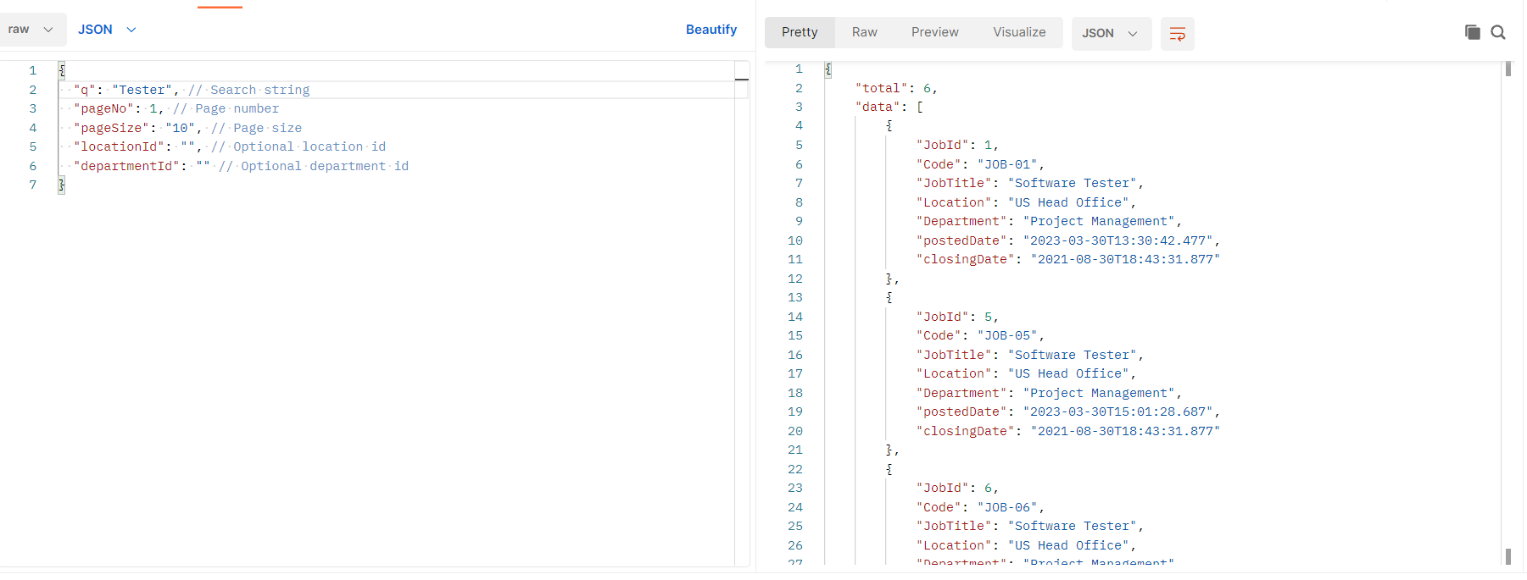

For search string “Tester” 3 records are shown out of total 6 records

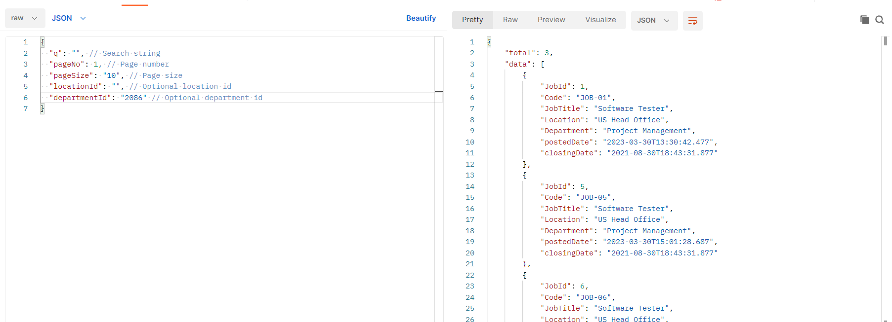

For Department ID = 2086, only 3 records are available

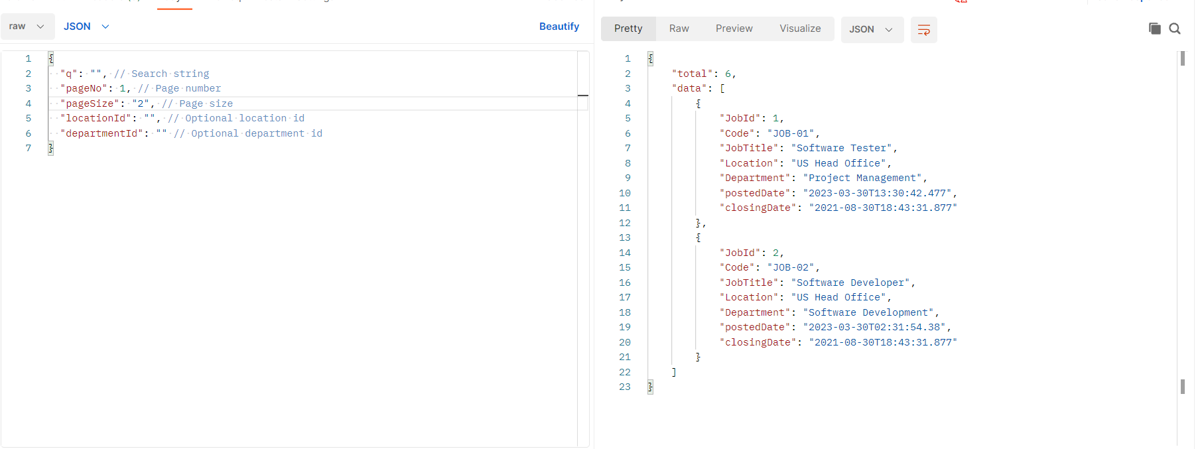

For 2 page size , only 2 records are shown on each page out of total 6 records

**Details API**

**GET /api/v1/jobs/{id}**

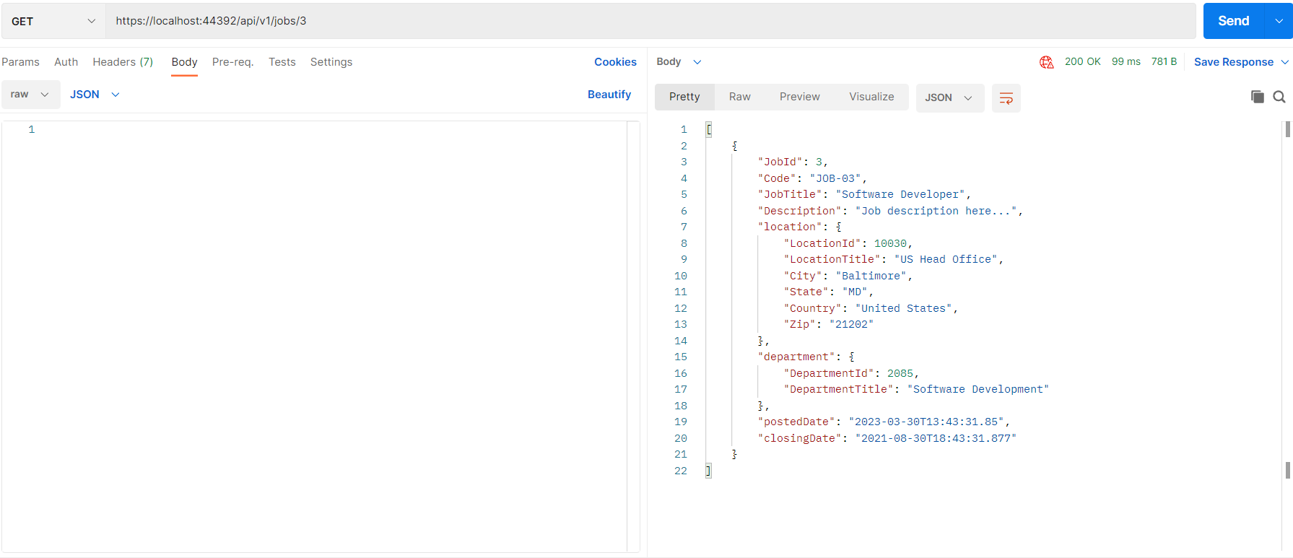

Response

[

    {

        "JobId": 3,

        "Code": "JOB-03",

        "JobTitle": "Software Developer",

        "Description": "Job description here...",

        "location": {

            "LocationId": 10030,

            "LocationTitle": "US Head Office",

            "City": "Baltimore",

            "State": "MD",

            "Country": "United States",

            "Zip": "21202"

        },

        "department": {

            "DepartmentId": 2085,

            "DepartmentTitle": "Software Development"

        },

        "postedDate": "2023-03-30T13:43:31.85",

        "closingDate": "2021-08-30T18:43:31.877"

    }

]